1. Order created_at DESC

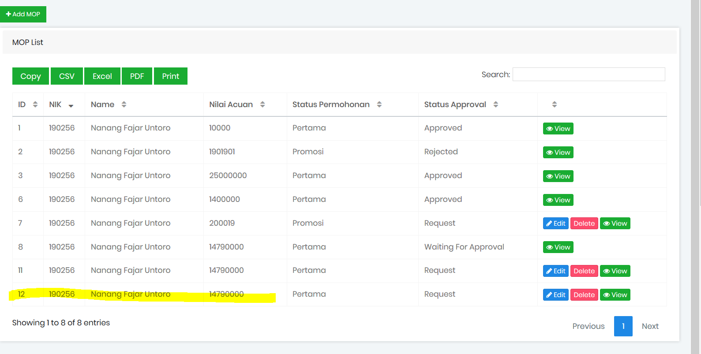

1. Cek setiap button back list

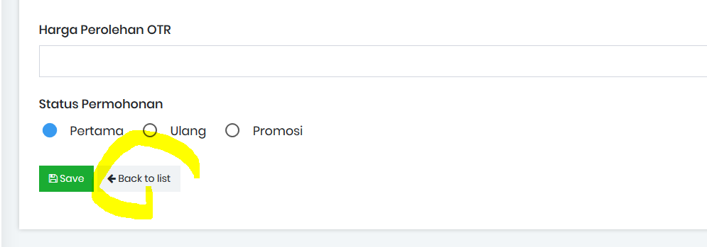

1. - Waiting approval **Nama Atasan,** semua waiting approval kasih nama di

* Status Approval

1. Waiting Approval Atasan
2. TIdak ada Waiting Approval HR, di menu HR hanya list COP, NOP,MOP

* Data sudah di kirim, tidak bisa edit/delete

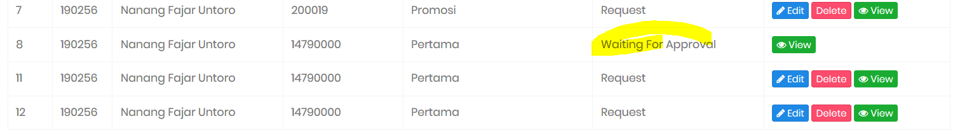

1. Tambahkan di detail/show

* Merek
* Jenis
* Tahun
* Cc
* Harga otr
* Historical approval tidak sesuai

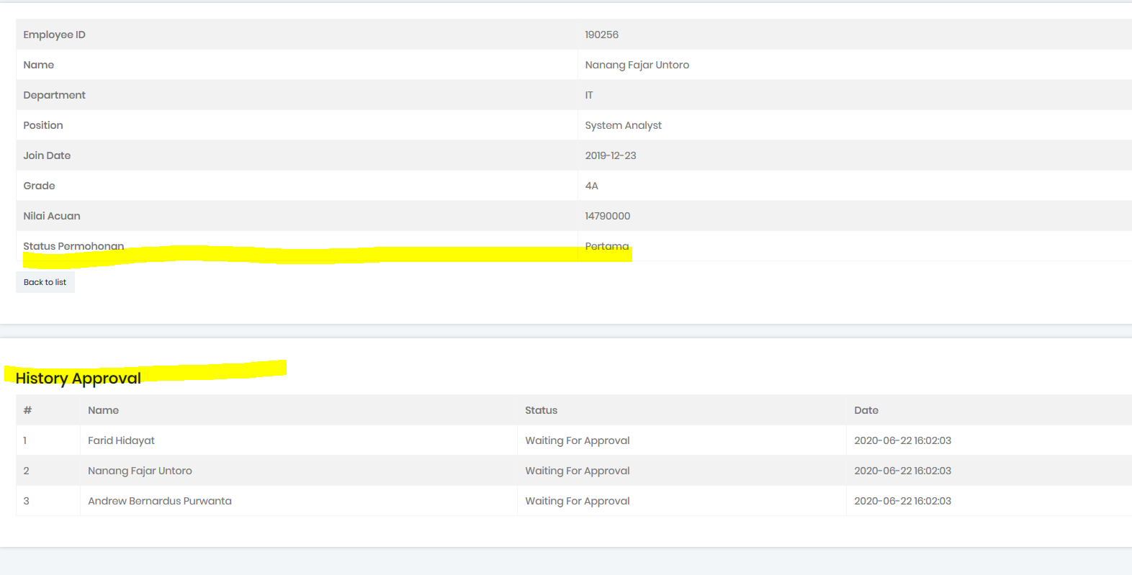

1. Belum ada approve by email

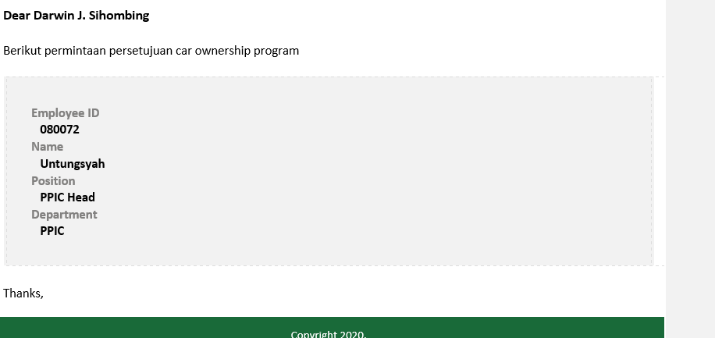

1. Tambahkan informasi pada body email
   1. Merek
   2. Jenis
   3. Tahun
   4. Cc
   5. Harga otr

* Berlaku untuk COP, MOP, NOP

````````````````````````````````````````````````````````````````````````````````````````````````````````````````````````````````````

COP Juga ya

````````````````````````````````````````````````````````````````````````````````````````````````````````````````````````````````````